Machine Learning And Industry 5.0

INTRODUCTION
In recent years, there has been an increased interest in the emergent Industry 5.0 (I5.0) paradigm. The next wave of industrial revolution of I5.0 aims to intelligently elevate the collaboration between human workers and machines to improve efficiency, productivity, customization, and product quality (Pizon ́ & Gola, 2023; Santhi & Muthuswamy, 2023). Our research refers to the I5.0 concept as “a combination of organizational principles and technologies to design and manage operations and supply chains as resilient, sustainable, and human-centric systems” (Ivanov, 2023, p. 1683). However, while the new I5.0 paradigm has considerable potential for revolutionizing the current industrial and manufacturing practices, it has many challenges that it needs to cover to gravitate towards the future of manufacturing (Tavares et al.,2022). (https://doi.org/10.1016/j.digbus.2024.100090)
The Industry 4.0 approach that was coined approximately ten years ago has become a worldwide-accepted term (Xu, et al., 2021). Industry 4.0 is recognized for leveraging cutting-edge technologies, including cyber-physical systems (CPS), the Internet of Things (IoT), and cloud computing, to enable smart, automated factories (Lu, 2017; Zangiacomi,et al., 2020). Industry 5.0 aims to create an interdependent connection between people, where people and machines work together to achieve higher productivity, efficiency, and quality levels (Ghobakhloo, 2018). This requires developing and implementing advanced technologies such as collaborative robots, augmented reality, and artificial intelligence designed to work with humans safely and efficiently. (https://doi.org/10.1016/j.joitmc.2024.100384)
With the rapid transition of Industry 4.0 to 5.0, modern industrial physio-chemical processes are characterized by two critical challenges: process safety and final product quality [1,2]. Industrial processes include significant equipment, and these units have structural and operational interactions.( https://doi.org/10.1016/j.jii.2024.100709)
The advent of Industry 5.0 marks a pivotal moment in the evolution of manufacturing and industrial practices, heralding a new era that prioritizes sustainability alongside technological innovation (Battaglia, Galati,Molinaro, & Pessot, 2023; Contini, Peruzzini, Bulgarelli, & Bosi, 2023; Mariani & Borghi, 2019; Valette, Bril El-Haouzi, & Demesure, 2023). This concept, although emerging, is rapidly gaining traction as it seeks to reconcile the often conflicting goals of economic growth and environmental stewardship (Ghobakhloo et al., 2023; Javaid, Haleem, Singh, Suman, & Gonzalez, 2022; Karmaker, Bari, et al., 2023). The essence of Industry 5.0 lies in its focus on integrating human creativity and craftsmanship with the capabilities of smart systems and automation to enhance efficiency, productivity, and environmental sustainability (Cronin & Doyle-Kent, 2022). This review article provides a comprehensive overview of the emerging trends and challenges that Industry 5.0 presents for achieving a green future.
At its core, Industry 5.0 represents a significant shift from the fourth industrial revolution's emphasis on automation and data exchange in manufacturing technologies to a more inclusive approach that in corporates human intelligence and sustainable practices (Rahmani, Karimi, Resende, Abrantes, & Lopes, 2023; Strazzullo, Moro, & Cricelli,2023). This paradigm shift underscores the importance of sustainable development in the face of global challenges such as climate change, resource depletion, and environmental degradation (J. Z. Wang et al., 2023; Wen, Zhang, Chang, Anugrah, & Affandi, 2023). It advocates for a balanced approach that leverages technology to enhance human capabilities while ensuring environmental protection and resource efficiency. The convergence of Industry 5.0 with sustainability principles is pivotal, offering a pathway to harmonize industrial development with the planet's ecological limits. (https://doi.org/10.1016/j.igd.2024.100173)
Industry 5.0 builds robustly upon the technological foundation established by Industry 4.0, but it is crucial to distinguish between these two paradigms. Industry 4.0 was primarily focused on digitizing and automating industrial processes, leading to significant productivity gains and economic growth (Santhi and Muthuswamy, 2023). However, this focus often neglected critical environmental and social implications, prompting necessary discussions about the adverse effects of technological advancements, including job displacement and social inequalities (Grybauskas et al., 2022). In sharp contrast, Industry 5.0 articulates a society-driven agenda that effectively guides the digital transformation of industries in alignment with sustainability objectives (Destouet et al., 2023). It redefines the purpose of industries, positioning them not only as wealth creators but as active agents in solving societal challenges (Sindhwani et al., 2022). In this context, Industry 5.0 decisively aligns economic growth with environmental preservation and social equity (Kardush et al., 2022; Waheed et al., 2022). The urgent emergence of Industry 5.0, in conjunction with the ongoing evolution of Industry 4.0, is a direct response to escalating sustainability concerns. The stark realities of climate change, biodiversity loss, and resource depletion demand that industries take serious accountability for their environmental impact. The rising tide of ethical consumerism and societal expectations compel businesses to act responsibly, further underscoring the critical relevance of Industry 5.0.
Industry 5.0, also known as the Fifth Industrial Revolution, represents a new stage of industrialization. This involves humans collaborating with advanced technology and AI-enabled robots to improve workplace processes. Unlike Industry 4.0, which focused on efficiency through robots and smart machines, Industry 5.0 focuses on human impact. Key technologies include IoT (Internet of Things) and Big Data, which support human work and capabilities. Industry 5.0 emerged as a potential amendment to Industry 4.0. It emphasizes human-centricity, sustainability, and resilience in manufacturing processes. The goal is to create eco-friendly, adaptable systems that promote workforce well-being. Industry 5.0 recognizes that technology should empower humans, not replace them. It envisions a future where humans work alongside robots, leveraging technology for better results [3]. Sustainability and resilience are integral to this vision. (https://drive.google.com/file/d/154cgNJQ4AXFyypZLnecnA8qsuLO3on_-/view).

History of Industrial Revolutions:
First Industrial Revolution: The first IR took place in the late 18th and early 19th century. It was characterized by the transition from manual labor and hand production methods to mechanization through the use of water and steam power. This revolution introduced new manufacturing processes, such as the spinning mills and the steam engines, which increased production efficiency and led to factory growth. IR 1.0 primarily focused on textile manufacturing and the steam engine innovations [5].
Second Industrial Revolution: The second IR occurred in the late 19th and early 20th centuries and was driven by advancements in technology, especially in electricity, steel production, and the use of machinery. The major drawback of IR 2.0 is the automation which led to IR 3.0 through the introduction of semiconductors and computers.
Third Industrial Revolution: The third IR, often called the Digital Revolution or the Information Age, emerged in the late 20th century with the advent of computers, electronics and telecommunications. This revolution has changed the way information was processed, stored, and shared. This has led to the automation of various tasks, the rise of the Internet, and the development of digital technologies that have revolutionized industries such as telecommunications, entertainment and commerce.

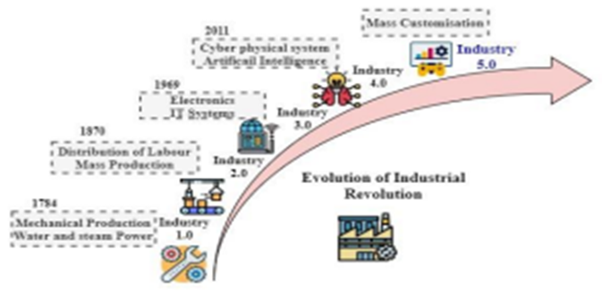

Fourth Industrial Revolution: The fourth IR is the continuous industrial transformation through the integration of digital technology, AI and IoT. It is characterized by the convergence of physical, digital and biological systems. This revolution is marked by advances in areas like robotics, automation, machine learning, nanotechnology and biotechnology. It is expected to have a major impact on various fields, such as manufacturing, healthcare, transportation, and agriculture. IoT, Smart manufacturing, Industrial IoT (IIoT), and Cloud manufacturing are the four main forces behind IR 4.0. The evolution of industrial revolutions is vividly shown in Figure 1 which depicts the industrial revolution transition from Industry 1.0 to Industry 5.0.
Fifth Industrial Revolution: IR 5.0 represents a recent revolution in which human-machine collaboration plays a key role in improving manufacturing processes. The transition from IR 4.0 to IR 5.0 will create higher-value professions, give designers more freedom and responsibility, and focus on personalized experiences for employees and clients [7]. In contrast to previous IRs that emphasized mass production and customization, IR 5.0 focuses on personalization and creative production [10].
(https://drive.google.com/file/d/154cgNJQ4AXFyypZLnecnA8qsuLO3on_-/view)
Explanations and modernization
Explanation of definitions
- The term Industry 5.0 refers to people working with robots and smart machines. It is about robots helping humans work faster by leveraging advanced technologies such as big data analytics [27, 28].
- Industry 5.0 is termed as the revolution in which man and machine are findings ways to work for improvement means and efficiency of the manufacturing production [29].
- Ocicka and Turek [30] suggested that Industry 5.0 is compelled with various industries technologists, philosophies, and others to focus on the human factors and technologies in the manufacturing systems.
- Industry 5.0 is considered the edge of the smart factory, where it communicates with robots and humans [13, 31]. It uses social networks for communication purposes among humans and electronics components.
- Industry 5.0 added human-centric, sustainable, and resilient concepts to the industrial revolution. It will revolutionize the manufacturing systems worldwide by preventing repetitive tasks from human workers [32]. The intelligent robots will penetrate manufacturing supply chains as well as the workflow of the production to unparalleled levels.

The evolution of Industry 5.0 is done in the retail, healthcare, finance, manufacturing and other industries. The lessons learned are discussed from various studies, applications, and enabling technologies of Industry 5.0. Figure 4 illustrates the opportunities, limitations, and future research directions on industry 5.0.

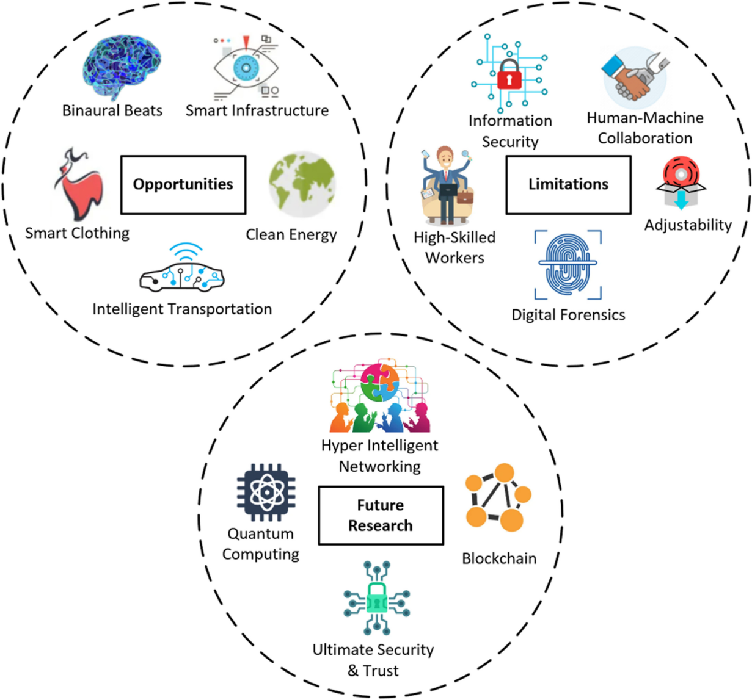

Different Sectors of Industry 5.0 (https://doi.org/10.1016/j.artmed.2024.103000)

Healthcare industry
Healthcare Industry 1.0 describes the fundamental hospital (clinic) and patient interaction. A patient visits the clinic to meet a doctor and other healthcare teams for a checkup. The clinic consults with the patient, conducts tests, diagnoses the disease, and prescribes medicine. For hundreds of years, this system has been in use for the delivery of healthcare. Due to the excessive use of electric power, mass production, and assembly line production, the new industrial revolution from the mid-eighteenth century to the nine. The twentieth century is also called the healthcare Industry 2.0 [25]. Multiple new medical tools have been introduced for diagnosing, monitoring, and treating patients’ healthcare. Healthcare Industry 3.0 is primarily conducted on-site, is mainly biomedical, and is focused primarily on infectious diseases like COVID-19 [23,24].
Since we move on to the 21st century, the healthcare industry aspires to connect to the cyber–physical system [25]. Then, Big Data Analytics (BDA) and AI methods are utilized with IoT and its accompanying services. Healthcare Industry 4.0 [26] is conducted in multidisciplinary centers and covers broader health issues, including Non-Communicable Diseases (NCD) and disparities. It includes merging the real world with the virtual world based on the physical cyber production system [20,21,23,26]. The final stage of the healthcare industry is Industry 5.0, which flips the industry operational models by adapting to customers’ needs and recognizing the customer’s core role. Industry 5.0 focused on customer relationship management and personalized healthcare [27,28].

Agriculture Industry
In the Agriculture industry, discriminating weeds from plants is necessary in weed management,regardless of the method that is chosen, i.e., using chemical or non-chemical. In this paper, we focus on the discussion of weed control applications, their recent advances, and also challenges. The steps to do weed-crop discrimination can be simply explained as follows. Initially, the images are captured using robots or UAVs equipped with cameras. The images must be free from any background interference (e.g., soil). Trained experts can be employed to label and distinguish between the weeds and the crops in the images. If any challenges arise during image acquisition, publicly available datasets with annotations can be utilized as an alternative. Afterward, the classification task begins by selecting the features, which can be performed either manually or automatically. ML algorithms use the selected features for learning the patterns, while Deep Learning (DL), which is a subset of ML, can be utilized to perform both automatic feature selection and classification. This concept is depicted in Fig. 4 ,5 and 6. The review of the state-of-the-art technology for weed-crop discrimination will be discussed in the following structure. The paper starts by examining the motivation behind weed-crop recognition task in Section 1. Moreover, various data acquisition methods and preprocessing strategies aimed at distinguishing between vegetation and the background (background removal) are presented in Section 2 and Section 3, respectively. Subsequently, feature-based weed-crop recognition techniques are presented in Section 4. Next, ML and DL approaches for classification tasks are elaborated in Section 5. The publicly available datasets are discussed briefly in Section 6. The challenges and opportunities can be found in Section 7. Finally, the paper concludes the discussion in Section 8 where the areas of weed emergence are detected to focus the application of weedicide, and 2) real time monitoring method that simultaneously detects and controls weeds by spraying weedicide on the spot. Existing techniques for image processing provide extremely promising outcomes under optimal imaging conditions, even though they can be quite challenging under real time conditions. The overlap of plant leaves and weeds at different stages of growth makes them synonymous to each other. In addition, the leaves are often occluded, discolored or damaged by undesired materials which alter the morphological as well as spectral characters of the leaves. As the lighting conditions change during different times in a day, the shadows formed by the plant canopy and the solar inclination can directly impact the colour of vegetation. Furthermore, different plant growth stages also result in variations of the morphological, textural, and spectral attributes to leaves. This paper focuses on the discrimination between crop and weed using ML approaches. Note that traditional image processing techniques like Hough transform can also be used to discriminate between crop and weed (Bah et al., 2017). However, these approaches are not of our interest. Instead, we commonly use image processing techniques to extract the features like color, shape, etc. to be fed to the ML algorithms. The efficiency of these methods mostly depends on the manually designed features and have high dependence on image acquisition methods, pre-processing methods, and the standard of features extracted. Earlier studies in this category primarily used color co-occurrence matrix based texture analysis for images (Chang et al., 2012).
Manufacturing industry
Industry 5.0 is considered a new production model where it is focused on interaction among humans as well as machines. Industry 5.0 is involved in leveraging collaboration among increasing accurate machinery plus the innovative potential of human beings. In order to make manufacturing sustainable, it develops processes that repurpose and recycle the resources [56, 57]. There is also required to reduce the environmental impacts in the manufacturing industry. Additive manufacturing is required to increase personalization to optimize resource efficiency and waste. Industry 5.0 is revolutionizing the manufacturing systems across the globe by taking away repetitive tasks from human workers. mart manufacturing allows designers to protect design files of manufacturing items by storing them in the cloud with robust access control and usage of the manufacturing resources across various places [59]. Figure 2 pictorially illustrates a number of potential applications within industry 5.0.

Industry 5.0 technologies
The enabling technologies related to industry 5.0 include cloud computing, Blockchain, analytics of big data, IoT and 6G networks.
Cloud computing
Cloud computing is the delivery of computing services those are included databases, software, intelligence analytics, networks, and others [69]. This technology is offering efficient innovation and economics of the scale. This technology uses the internet to store and manage data on the remote servers, and then data is accessed via the internet. The cloud providers are manufacturing applications like IoT monitoring tools adopted for mobile and web usage. The cloud also supports the usage of API that can automate data normalization from diverse data production sources [74]. Edge computing devices handle data analytics equipped with limited computing resources to manage the business analyses. Global cooperative type of typical cloud ecosystems in critical sectors is pictorially demonstrated in Fig. 3.

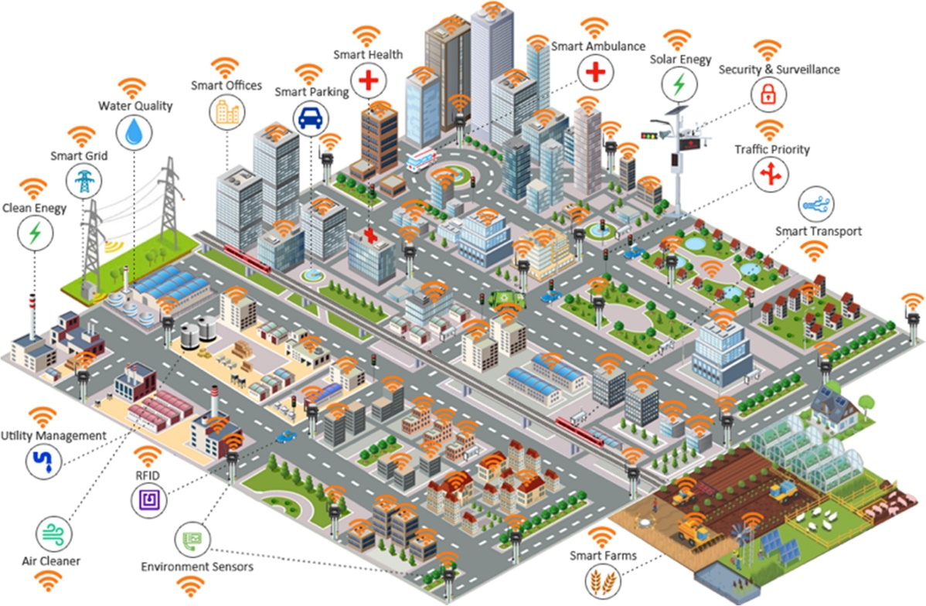

Fig: 3 Cloud Ecosystems in Critical Sectors
Big data analytics
Industry 5.0 is an innovative technology that enables utilizing 3D symmetry in the innovation ecosystem designs. Matheus et al. [70] mentioned that big data analytics is a complex procedure to examine big data to uncover data like hidden patterns, trends of the markets and others. It uses an advanced analytic method with diverse data sets, including structured and semi-structured data. It has massive data sets to store and process through traditional tools [15, 88, 89]. It is used as real-time data to enhance the competitive advantages of the business industry, focusing on providing possible recommendations on predictive discovery. Big data analytics is used to recognize discrepancies while the organization is leveraging a list of the root causes of the issues.

Blockchain
It is decentralized and distributed technology, where the digital ledger contains records named as blocks to record the transactions data. It is a shared ledger that can facilitate recording the transactions and tracking the assets in the business network [95]. The business is running on the information. Therefore, Blockchain technology delivers the data by providing shared and completed information stored in the immutable ledger that the network members access [96,97,98,99]. Blockchain technology helps the customers by tracking the orders, payments, production, etc. The network participants have distributed ledger records of transactions, which are recorded to avoid duplication of efforts and records in the database system [100].
6G and beyond
It is a sixth-generation standard for developing wireless interactions technologies that can support cellular data networks. 6G organizations are relied upon to display significantly greater heterogeneity than their ancestors [106]. They will probably help applications past current portable use situations, like virtual and increased reality (VR/AR), omnipresent moment correspondences, and inescapable knowledge of the Internet of Things (IoT). Normally, versatile organization administrators will embrace adaptable decentralized plans of action for 6G, with nearby authorizing, range sharing, framework sharing, and wise mechanized administration supported by versatile edge processing, artificial brainpower, short-parcel correspondence and Blockchain advances [107]. For industry 5.0, 6G networks are expected to meet the intelligent information society standards to deliver ultra-high reliability [108]. Artificial intelligence methods are used to get mobility predictions solutions to ensure network connectivity.

Applications in industry 5.0 (https://doi.org/10.1016/j.rcim.2024.102769)
(https://journalofcloudcomputing.springeropen.com/articles/10.1186/s13677-022-00314-5#Fig2)
The possibilities of Industry 5.0 are vast and diverse, as the integration of advanced technologies with human-centric design principles can transform the manufacturing industry in a myriad of ways. In this section, we will explore some of the key applications of Industry 5.0, including the use of smart factories [11], collaborative robots [59], healthcare [60], cloud manufacturing, sustainable manufacturing [11], predictive maintenance systems, and advanced data analytics. We will discuss how these technologies can improve efficiency, safety, and sustainability in manufacturing processes, and explore their potential to drive innovation and growth in various industries (see Fig 3.)

Smart hospital
Industry 5.0 is aimed to create a smart hospital with real-time capability. The technology can provide remote monitoring systems within healthcare [48]. It plays a key in making life better for the doctors. In the COVID-19 pandemic, doctors can use this smart healthcare technology to focus on infected patients and provide efficient data regarding better treatment [1, 49]. Even it also helps the students as well as medical students for needed medical training through the outbreak of COVID-19. Machine learning (ML) is applied to medical imaging, natural language processing, plus genetic data [7]. It is focused on the diagnosis of the diseases, detection, plus prediction of the diseases.

Cloud computing
Cloud computing is the delivery of computing services those are included databases, software, intelligence analytics, networks, and others [69]. This technology is offering efficient innovation and economics of the scale. This technology uses the internet to store and manage data on the remote servers, and then data is accessed via the internet. The cloud providers are manufacturing applications like IoT monitoring tools adopted for mobile and web usage. The cloud also supports the usage of API that can automate data normalization from diverse data production sources [74]. Edge computing devices handle data analytics equipped with limited computing resources to manage the business analyses. Global cooperative type of typical cloud ecosystems in critical sectors is pictorially demonstrated in Fig. 3.

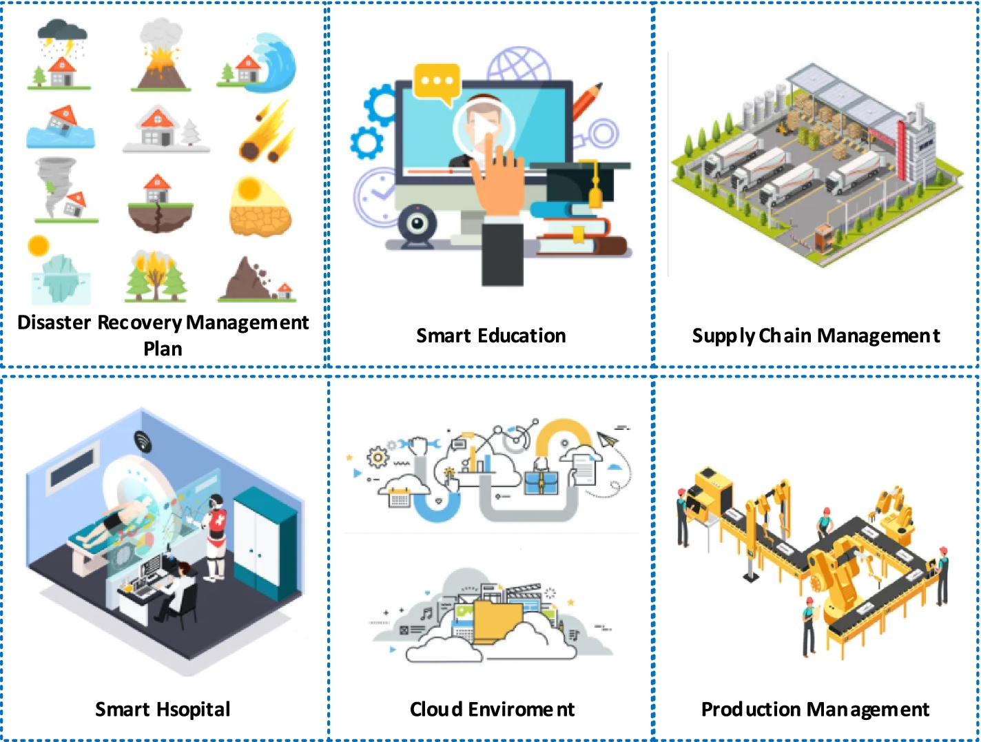

Fig. 3. Applications in Industry 5.0.
(https://journalofcloudcomputing.springeropen.com/articles/10.1186/s13677-022-00314-5#Fig2)

Supply chain management
Industry 5.0 seeks to take automated and intelligent digital ecosystems and pair them with the human touch [65, 66]. There is leveraging of human elements in such a process that it helps customize the end-user experiences and optimized workflows.
Human intelligence is worked with the empowered way with cognitive computing along with intelligent automation abilities to enable hyper-personalization. The technologies like machine learning, robotic automation, and others are helping the employees increase business proficiency and deliver high value to the customers faster [12, 67]. From delivering the raw materials, transactions, transportation, the ERP system manages the supply chain for the business organization [68].

Robotics and Computer-Integrated Manufacturing
HRC can greatly benefit workers in industry by increasing efficiency and productivity while reducing the risk of workplace injuries. By partnering with robots, workers can delegate repetitive or dangerous tasks to the robots, allowing them to focus on higher-value tasks that require human skills and expertise [30]. For example, robots can be used for tasks such as material handling, assembly, and quality control, freeing up human workers to focus on more complex tasks such as troubleshooting, problem-solving, and decision-making.
In addition to increasing efficiency, HRC can also improve the overall work environment by reducing the risk of workplace injuries [32]. Robots can perform tasks that are too dangerous or physically demanding for human workers, such as working in hazardous environments or handling heavy loads. This not only protects human workers, but also helps to reduce workplace accidents and injuries, which can be costly in terms of both human and financial resources [33].
Moreover, HRC can lead to the development of new and innovative products and processes, as human workers and robots can share their unique strengths and capabilities to solve problems and achieve common goals. By working together, human workers and robots can accomplish tasks that would be difficult or impossible to achieve independently, leading to greater innovation and competitiveness in industry. Human Collaborative Robots can have different applications and some of them are discussed below:
HRC has a wide range of applications in the automobile industry, from assembly and manufacturing to quality control and inspection [34]. The use of HRC in this industry can increase efficiency, reduce the risk of workplace injuries, and lead to the development of new and innovative products.
One example of an HRC system currently deployed in the automobile industry is the collaborative robot, or ‘‘cobot’’. Cobots are designed to work alongside human workers in shared workspaces, performing tasks such as material handling, assembly, and quality control [35,36]. They are equipped with sensors and safety features, such as force control, to ensure that they can work safely in close proximity to human workers.
Another example of an HRC system in the automobile industry is the use of robots for painting and finishing operations. These robots are equipped with advanced sensors and control systems that allow them to work in close collaboration with human workers, applying paint and other finishes to vehicles with precise control and high accuracy [37].
HRC systems are also used in the automobile industry for assembly operations, where robots are used to perform repetitive and physically demanding tasks, such as the assembly of car parts and components. This not only increases efficiency and reduces the risk of workplace injuries, but it also allows human workers to focus on higher-value tasks, such as quality control and inspection. Overall, the use of HRC in the automobile industry has the potential to revolutionize the way that work is performed, by increasing efficiency, reducing the risk of workplace injuries, and fostering innovation and competitiveness.
HRC in assembly line is a rapidly growing field in the manufacturing industry, where robots and human workers are integrated to increase efficiency and productivity. In assembly line operations, robots can perform repetitive and physically demanding tasks, while human workers can handle tasks that require dexterity and problem-solving skills [38– 40]. The integration of human workers and robots [41] in the assembly line allows for more efficient and effective use of resources, leading to higher overall productivity.
Some examples of currently deployed HRC systems in assembly lines include KUKA’s HRC system, Universal Robots’ UR+ Platform, and ABB’s YuMi. KUKA’s HRC system uses advanced sensor technology to allow robots and human workers to work safely in close proximity. Universal Robots’ UR+ Platform enables the integration of third-party tools and accessories with its collaborative robots, allowing human digital twins for simulation and testing of different scenarios, including HRI, without risking harm to the physical system or to the human collaborators [13]. One of the primary benefits of using a digital twin in HRC is the ability to test and optimize performance. The digital twin can be used to evaluate different control algorithms and interaction strategies to determine the best approach for HRC. This can help to improve the efficiency and effectiveness of the collaboration and reduce the risk of accidents or incidents. Another advantage of using digital twins in HRC is the ability to anticipate and mitigate potential safety concerns. For example, the digital twin can be used to simulate the behavior of a robot in hazardous environments and to assess the potential impact of that behavior on human collaborators. This can help to identify potential hazards and develop strategies to minimize risks. The use of digital twins also facilitates communication and coordination between human and robot collaborators. The digital twin can provide a shared visual representation of the physical system, which can help to improve the understanding of the system and its behavior. This can improve the accuracy of decision-making and reduce the likelihood of misunderstandings or miscommunications between human and robot collaborators. Therefore, the use of digital twins in HRC offers several benefits that can address the complexities of this type of collaboration. The technology can be used to optimize performance, anticipate and mitigate safety concerns, and facilitate communication and coordination. By leveraging the capabilities of digital twins, organizations can improve the efficiency and effectiveness of HRC workers and robots to work together on the assembly line. ABB’s YuMi is a dual-arm collaborative robot designed for use in assembly line operations, featuring built-in safety features to allow it to work safely alongside human workers.
BENEFITS AND FEATURES OF INDUSTRY 5.0 WITH THE USE OF AI
The main benefits that AI will bring to IR 5.0 are evolution to connected environments, cognitive support, automation and cognitive biases, leadership adaptation in organizational functioning. IR 5.0 has many features with the use of AI. Figure 3 lists out all the features. The features of IR 5.0 with the use of AI are summarized below.
1. Environment Friendliness: AI technologies such as ML and DL can contribute to environmental sustainability by providing solutions to maintain a positive environmental impact [29]. In the microalgae industry, AI benefits product quality and promotes improved living standards in society [30].
2. Innovation Management: Proper alignment of the IR 5.0 enterprise model and AI information system is very important for effective implementation of innovation [31]. A robust innovation management framework and policies are required to maximize the potential benefits of IR 5.0 for business and customer needs.
3. Design Thinking: Design thinking combines technology and innovation policies with a company's business approach to create a sustainable environment for IoT and IR 5.0. By focusing on customer value and balancing reliability and effectiveness, design thinking enables companies to develop extraordinary ideas and seize opportunities [32].
4. Risk Detection: AI-supported application of actionable system models helps monitor and detect risks and adapts to corporate strategy. ML algorithms and automated systems with AI and machine learning capabilities can help reduce risks in processing and facilitate risk detection [33].
5. Intelligent Systems: AI techniques enables machines to learn and execute tasks autonomously. DL strategies such as classification, regression, and clustering methodologies provide solutions for intelligent systems. Intelligent autonomous systems, also known as "COBOTS," combine sensor technology and predictive behavior, paying attention to safety standards and work-related risks [34].
6. Intelligent Devices: Powered by purpose-built AI chipsets, on-device AI brings computing to the edge to manage privacy risks, reduce latency, and minimize network dependency. Smart devices augment customer knowledge and automatically deliver personalized services and experiences. In the medical industry, AI is monitoring various aspects such as blood sugar levels and insulin administration. In manufacturing, intelligent factories automate processes with the support of industrial robots.
(https://drive.google.com/file/d/154cgNJQ4AXFyypZLnecnA8qsuLO3on_-/view)

